IBM Blockchain   
Proof of Technology  
Blockchain Unchained

Lab Three – Bluemix - Exercises

#### Contents

Section 1. Creating a Blockchain Service on Bluemix 4

1. Create a New Blockchain Service 4

2. Sample Apps - Editing your first Chaincode 5

Appendix A. Notices 7

Appendix B. Trademarks and copyrights 9

#### Overview

The aim of this lab is to introduce you to chaincode development by showing you how to create and deploy your first chaincode to a new blockchain service in Bluemix.

##### Introduction

Prerequisites:

* + A Bluemix account IBM ID
  + Access to [www.Bluemix.net](http://www.Bluemix.net)
  + A Bluemix account
  + Preferably have completed Labs one and two (Blockchain Explained and Blockchain Explored).
  + Firefox or Chrome browsers.

Optional requirements, if you want to edit and compile Chaincode yourself

* + GitHub account and tools (from <https://github.com/>)
  + GO Lang compiler installed (from <https://golang.org/dl/>)

# Creating a Blockchain Service on Bluemix

## Create a New Blockchain Service

1. Open a web browser and go to [www.bluemix.net](http://www.bluemix.net).

|  |  |
| --- | --- |
| sign-troubleshooting | It is recommended to use Firefox or Chrome.  Some people have previously reported problems working with Bluemix in Internet Explorer and Safari. |

1. Click ‘Sign Up’ or ‘Log In’ to create a new Bluemix account or log into your existing account.
2. Select  from the top bar
3. Scroll down to the Network section and select **Blockchain**

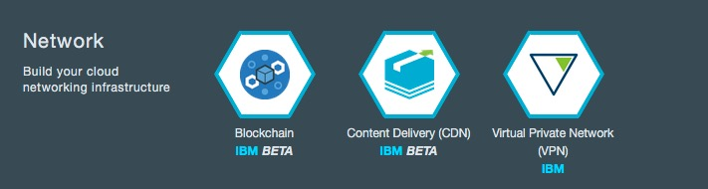

Review the service description and information about the service.

1. Select  to create a new Blockchain service leaving all the settings at their defaults. Note: this assumes your ID has an “Org” and a “space” associated with it.

This service welcome screen will give you details about IBM Blockchain Network Service Test Environment. Review this page for more information. For a full description of the Blockchain service please go to: <https://console.ng.bluemix.net/docs/services/blockchain/ibmblockchain_overview.html>

1. From the “Network Service Test Environment” welcome screen click on the “DOCS” button



## Sample Apps - Editing your first Chaincode

1. Click on “SAMPLE APPS AND TUTORIALS” in the left hand margin.

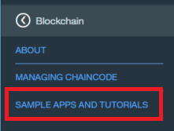

1. Click on “Using Hello Chaincode” in the left hand margin.

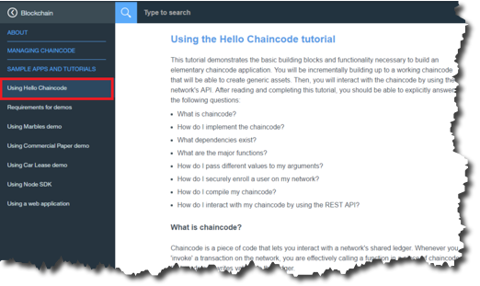

1. You are now going to follow the steps on the “Using the Hello Chaincode tutorial”. There are two ways through this section:
2. If you are a developer who needs to write Chaincode, you should follow the steps fully including setting up “Go” and using “Git” to change and deploy Chaincode. In summary the steps you will be following are:
   1. Setting up the Environment
   2. Setting up GitHub and forking the example “Hello Chaincode” repository.
   3. Clone the “Hello Chaincode” fork to your local system. Make sure you clone the forked version rather than the original.

|  |  |
| --- | --- |
| sign-troubleshooting | If you accidently clone the original repository use :  "git remote set-url origin https://github.com/<yourGitID>/learn-chaincode" to point to your fork rather than original |

* 1. Editing the chaincode_start.go file to add in new capability for Invoking and Querying the Chaincode
  2. Committing your local changes with "git commit -a"
  3. Uploading you changes back to your forked repository with "git push"
  4. Interacting with your changes using the Swagger API to Deploy, Invoke and Query the new Chaincode you made

1. If you just want to see how Chaincode works, you do not need to follow the steps on setting up “Go” and using “Git” to make changes. Instead, you can just read the earlier sections and simply deploy the “Finished” version of the Chaincode directly when you get to the “Deploying the Chaincode” section and work with that.
2. Notices

This information was developed for products and services offered in the U.S.A.

IBM may not offer the products, services, or features discussed in this document in other countries. Consult your local IBM representative for information on the products and services currently available in your area. Any reference to an IBM product, program, or service is not intended to state or imply that only that IBM product, program, or service may be used. Any functionally equivalent product, program, or service that does not infringe any IBM intellectual property right may be used instead. However, it is the user's responsibility to evaluate and verify the operation of any non-IBM product, program, or service.

IBM may have patents or pending patent applications covering subject matter described in this document. The furnishing of this document does not grant you any license to these patents. You can send license inquiries, in writing, to:

IBM Director of Licensing  
IBM Corporation  
North Castle Drive  
Armonk, NY 10504-1785  
U.S.A.

For license inquiries regarding double-byte (DBCS) information, contact the IBM Intellectual Property Department in your country or send inquiries, in writing, to:

IBM World Trade Asia Corporation  
Licensing  
2-31 Roppongi 3-chome, Minato-ku  
Tokyo 106-0032, Japan

**The following paragraph does not apply to the United Kingdom or any other country where such provisions are inconsistent with local law:** INTERNATIONAL BUSINESS MACHINES CORPORATION PROVIDES THIS PUBLICATION "AS IS" WITHOUT WARRANTY OF ANY KIND, EITHER EXPRESS OR IMPLIED, INCLUDING, BUT NOT LIMITED TO, THE IMPLIED WARRANTIES OF NON-INFRINGEMENT, MERCHANTABILITY OR FITNESS FOR A PARTICULAR PURPOSE. Some states do not allow disclaimer of express or implied warranties in certain transactions, therefore, this statement may not apply to you.

This information could include technical inaccuracies or typographical errors. Changes are periodically made to the information herein; these changes will be incorporated in new editions of the publication. IBM may make improvements and/or changes in the product(s) and/or the program(s) described in this publication at any time without notice.

Any references in this information to non-IBM Web sites are provided for convenience only and do not in any manner serve as an endorsement of those Web sites. The materials at those Web sites are not part of the materials for this IBM product and use of those Web sites is at your own risk.

IBM may use or distribute any of the information you supply in any way it believes appropriate without incurring any obligation to you.

Any performance data contained herein was determined in a controlled environment. Therefore, the results obtained in other operating environments may vary significantly. Some measurements may have been made on development-level systems and there is no guarantee that these measurements will be the same on generally available systems. Furthermore, some measurements may have been estimated through extrapolation. Actual results may vary. Users of this document should verify the applicable data for their specific environment.

Information concerning non-IBM products was obtained from the suppliers of those products, their published announcements or other publicly available sources. IBM has not tested those products and cannot confirm the accuracy of performance, compatibility or any other claims related to non-IBM products. Questions on the capabilities of non-IBM products should be addressed to the suppliers of those products.

All statements regarding IBM's future direction and intent are subject to change or withdrawal without notice, and represent goals and objectives only.

This information contains examples of data and reports used in daily business operations. To illustrate them as completely as possible, the examples include the names of individuals, companies, brands, and products. All of these names are fictitious and any similarity to the names and addresses used by an actual business enterprise is entirely coincidental. All references to fictitious companies or individuals are used for illustration purposes only.

COPYRIGHT LICENSE:

This information contains sample application programs in source language, which illustrate programming techniques on various operating platforms. You may copy, modify, and distribute these sample programs in any form without payment to IBM, for the purposes of developing, using, marketing or distributing application programs conforming to the application programming interface for the operating platform for which the sample programs are written. These examples have not been thoroughly tested under all conditions. IBM, therefore, cannot guarantee or imply reliability, serviceability, or function of these programs.

1. Trademarks and copyrights

The following terms are trademarks of International Business Machines Corporation in the United States, other countries, or both:

|  |  |  |  |  |  |  |
| --- | --- | --- | --- | --- | --- | --- |
| IBM | AIX | CICS | ClearCase | ClearQuest | Cloudscape |  |
| Cube Views | DB2 | developerWorks | DRDA | IMS | IMS/ESA |  |
| Informix | Lotus | Lotus Workflow | MQSeries | OmniFind |  |  |
| Rational | Redbooks | Red Brick | RequisitePro | System i |  |  |
| *System z* | *Tivoli* | *WebSphere* | *Workplace* | *System p* |  |  |

Adobe, the Adobe logo, PostScript, and the PostScript logo are either registered trademarks or trademarks of Adobe Systems Incorporated in the United States, and/or other countries.

IT Infrastructure Library is a registered trademark of the Central Computer and Telecommunications Agency which is now part of the Office of Government Commerce.

Intel, Intel logo, Intel Inside, Intel Inside logo, Intel Centrino, Intel Centrino logo, Celeron, Intel Xeon, Intel SpeedStep, Itanium, and Pentium are trademarks or registered trademarks of Intel Corporation or its subsidiaries in the United States and other countries.

Linux is a registered trademark of Linus Torvalds in the United States, other countries, or both.

Microsoft, Windows, Windows NT, and the Windows logo are trademarks of Microsoft Corporation in the United States, other countries, or both.

ITIL is a registered trademark, and a registered community trademark of The Minister for the Cabinet Office, and is registered in the U.S. Patent and Trademark Office.

UNIX is a registered trademark of The Open Group in the United States and other countries.

Java and all Java-based trademarks and logos are trademarks or registered trademarks of Oracle and/or its affiliates.

Cell Broadband Engine is a trademark of Sony Computer Entertainment, Inc. in the United States, other countries, or both and is used under license therefrom.

Linear Tape-Open, LTO, the LTO Logo, Ultrium, and the Ultrium logo are trademarks of HP, IBM Corp. and Quantum in the U.S. and other countries.



© Copyright IBM Corporation 2016.

The information contained in these materials is provided for informational purposes only, and is provided AS IS without warranty of any kind, express or implied. IBM shall not be responsible for any damages arising out of the use of, or otherwise related to, these materials. Nothing contained in these materials is intended to, nor shall have the effect of, creating any warranties or representations from IBM or its suppliers or licensors, or altering the terms and conditions of the applicable license agreement governing the use of IBM software. References in these materials to IBM products, programs, or services do not imply that they will be available in all countries in which IBM operates. This information is based on current IBM product plans and strategy, which are subject to change by IBM without notice. Product release dates and/or capabilities referenced in these materials may change at any time at IBM’s sole discretion based on market opportunities or other factors, and are not intended to be a commitment to future product or feature availability in any way.

IBM, the IBM logo and ibm.com are trademarks of International Business Machines Corp., registered in many jurisdictions worldwide. Other product and service names might be trademarks of IBM or other companies. A current list of IBM trademarks is available on the Web at “Copyright and trademark information” at www.ibm.com/legal/copytrade.shtml.

